Analytics Report: NYC Yellow Taxi Business Analysis
Task 5: Analytics Report & Insights Documentation | Data Engineer Internship | Santosh
Audience: the operations manager of a taxi fleet. Data: official NYC Taxi & Limousine Commission (TLC) Yellow Taxi trip records for August 2026 (3.34 million trips), joined with the TLC Taxi Zone Lookup table.

1. Executive Summary
A taxi fleet earns money only while its cars are carrying paying passengers, so the key business question is simple: when, where and on which kind of trip does a car earn the most? I analysed every yellow taxi trip in August 2026 (3,134,641 trips after cleaning) to answer it.
Headline numbers
KPI | Value | KPI | Value
Trips (clean) | 3,134,641 | Revenue per mile | $8.03
Total passenger spend | $94.2 million | Revenue per trip-minute | $1.74
Average per trip | $30.05 | Average trip | 3.74 miles, 17.3 min
Median fare | $15.60 | Average speed | 11.6 mph
Card share of trips | 63.4% | Airport share of trips / revenue | 9.2% / 23.1%

What the data shows
- Demand peaks in the evening, but the best money per minute is made at night and early morning. 17:00 to 22:59 holds 35.7% of all trips and 18:00 is the busiest hour (199,032 trips). Yet revenue per trip-minute is highest at 05:00 ($2.05) and lowest at 15:00 ($1.60), because slow daytime traffic eats minutes.
- Airports are the most valuable trips in the system. Trips that start or end at an airport are 9.2% of trips but 23.1% of revenue. They earn $2.07 per trip-minute against $1.66 for other trips. JFK alone brought in $11.2 million (average $77.54 per trip).
- Manhattan is the market. 87.0% of pickups and 74.5% of revenue are in Manhattan, and the top 10 pickup zones produce 40.5% of all revenue.
- Saturday is the strongest day. It averages 112,980 trips a day, about 31% more than Monday (86,351), and the Saturday 18:00 slot is the single busiest slot of the week (36,532 trips).
- Payments and tips are only partly visible. 63.4% of trips are paid by card (average tip $4.28), but 26.2% are Flex Fare (app) trips where almost no tip is recorded ($0.31 average), so tip analysis covers card trips only.

What I recommend
- Plan shifts around the evening peak (17:00 to 22:59, and Saturday evenings), keep a small night/early-morning airport group, and use 11:00 to 15:00 for maintenance and driver breaks.
- Build a standing airport strategy: take passengers to JFK and LaGuardia, and wait for a return fare.
- Position cars in the high-value Manhattan zones (Midtown Center, Penn Station, Times Square) in the evening, and fix the missing tip data on Flex Fare trips before judging driver earnings.

2. Business Objectives
Stakeholder: the operations manager of a taxi fleet who decides how many cars to put on the road, in which hours, and where to send them.
Objective: increase revenue per car-hour by matching supply to the places and times where trips are most valuable.
To reach this objective the analysis answers five business questions:
- When is demand highest, and does high demand also mean high earnings per minute?
- Which days of the week and which weekday-hour slots are the busiest?
- Which pickup zones and boroughs produce the most revenue?
- Which trip lengths are worth the most, per trip and per minute?
- How important are airport trips, and how do customers pay and tip?
Success measures (KPIs): trips, total revenue, revenue per trip, revenue per mile, revenue per trip-minute, average tip percentage, card share, and airport share of trips and revenue. "Revenue" in this report means the total amount the passenger paid (fare, extras, tolls, taxes and surcharges, and tip for card trips). It is not the net income of the driver or the fleet.

3. Data and Method

3.1 Data sources
- TLC Yellow Taxi Trip Records, August 2026 (parquet file): 3,336,716 rows and 21 columns, including pickup/drop-off time, distance, pickup and drop-off zone IDs, payment type, fare, tip and total amount.
- TLC Taxi Zone Lookup (CSV): 265 zones with borough and zone name. I joined it twice, once for the pickup zone and once for the drop-off zone.
- September 2026 was not yet published when I ran the notebook, so August 2026 is the latest complete month.

3.2 Cleaning
The raw file contains impossible records (zero distance, negative or huge fares, trips that last days). I removed them with these rules:
- pickup time inside August 2026 only (the file has a few stray dates)
- distance from 0.1 to 100 miles; fare from $0 (excluded) to $500; total amount up to $600
- duration from 1 to 180 minutes; average speed at most 80 mph
- exact duplicate rows removed
 | Rows
Raw rows | 3,336,716
Rows after cleaning | 3,134,641
Removed | 202,075 (6.06%)

Missing values: passenger_count is missing in 822,664 rows, which is exactly the number of Flex Fare trips (payment type 0), so these are almost certainly app-booked trips that do not report a passenger count. I kept them because passenger count is not used in any KPI. 2,392 trips have a pickup zone that is not in the lookup table and are shown as "Unknown".

3.3 New columns and definitions
- duration_min, speed_mph, hour, weekday, weekend flag, distance band
- Revenue per trip-minute = total amount divided by minutes in the car with a passenger. It does not include time spent waiting or looking for the next fare, so real earnings per working hour are lower.
- Tip % = tip divided by fare, for card payments only, because cash tips are not recorded.
- Airport trip = pickup or drop-off zone name contains "Airport" (JFK, LaGuardia, Newark).
- Tools: Python, pandas, NumPy, Matplotlib and Seaborn in Google Colab.

4. Analysis and Findings

4.1 Overall performance
In August 2026 the cleaned data contains 3,134,641 trips and $94.2 million of passenger spend. The average trip is short (median 2.1 miles, mean 3.74) but slow: 17.3 minutes at an average speed of only 11.6 mph. The average trip is worth $30.05, which is $8.03 per mile or $1.74 per minute. The median fare ($15.60) is far below the average revenue per trip ($30.05), because a small number of long trips and airport trips pull the average up. This matters for planning: the fleet's income is not spread evenly over trips.

4.2 Demand and earnings by hour of day
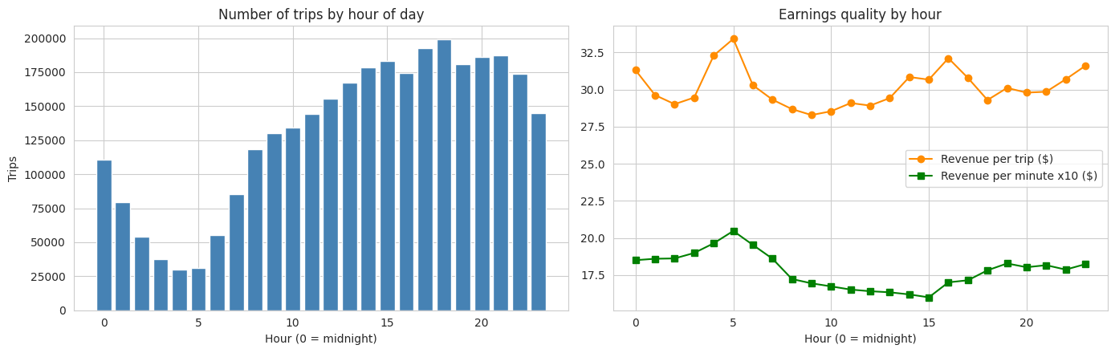
Figure 1: Trips (left) and earnings per trip and per minute (right) by hour
- Trips climb from a low of 29,798 at 04:00 to a peak of 199,032 at 18:00, which is 6.7 times more. The six hours from 17:00 to 22:59 hold 35.7% of all trips.
- Midnight to 05:59 holds only 10.9% of trips, but these hours pay well: revenue per trip-minute is $1.85 to $2.05 and the revenue per trip is highest at 05:00 ($33.42).
- Midday is the weakest period for earnings: from 11:00 to 15:00 revenue per trip-minute is only $1.60 to $1.65, even though many trips are happening. Slow traffic makes each minute worth less.
Business meaning: a busy hour is not the same as a profitable hour. Demand tells the fleet where passengers are, but revenue per minute tells it how well a car is used while carrying them.

4.3 Day of the week
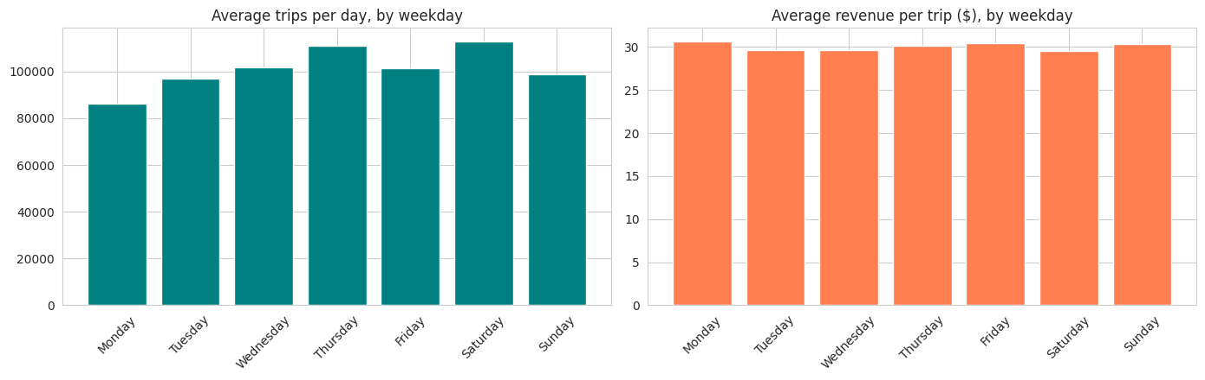
Figure 2: Average trips per day (left) and average revenue per trip (right) by weekday
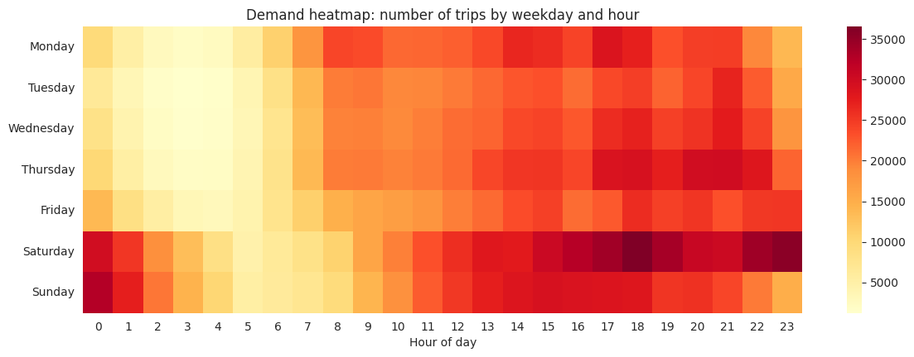
Figure 3: Number of trips by weekday and hour
- August 2026 has five Saturdays, Sundays and Mondays, so I compared the average trips per day instead of the totals. Saturday is the highest (112,980 trips a day), then Thursday (110,847). Monday is the lowest (86,351).
- Revenue per trip is nearly the same on every day ($29.56 to $30.67), and weekends ($29.93) are close to weekdays ($30.12). Weekends earn more because they have more trips, not because each trip pays more.
- The heatmap shows two different patterns. Monday to Friday has a strong evening peak around 17:00 to 18:00 (and a smaller morning rise around 08:00 to 09:00). Saturday builds all afternoon and reaches the maximum of the whole week at 18:00 (36,532 trips), with Saturday 23:00 (35,648) and 22:00 (34,265) next. Late Saturday night spills into the early hours of Sunday, where Sunday 00:00 and 01:00 are also among the busiest cells.

4.4 Where the money is: zones and boroughs
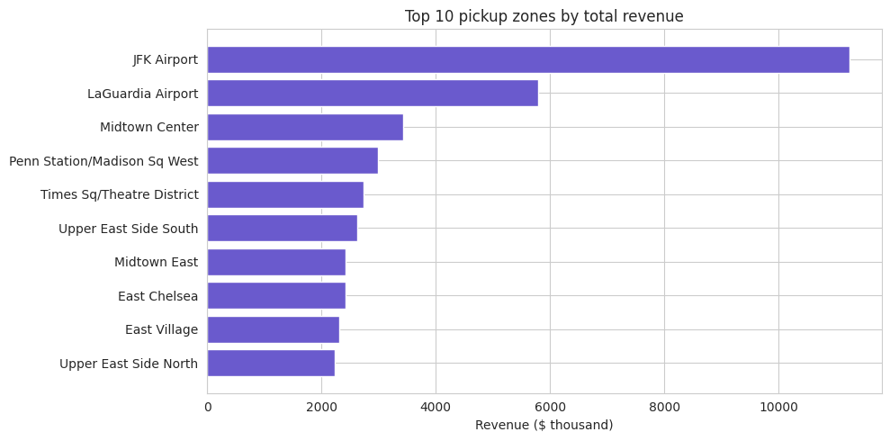
Figure 4: Top 10 pickup zones by total revenue
Pickup zone | Trips | Revenue ($) | Per trip ($) | Avg miles
JFK Airport | 145,049 | 11,246,594 | 77.54 | 14.78
LaGuardia Airport | 84,709 | 5,796,256 | 68.43 | 9.64
Midtown Center | 129,874 | 3,423,164 | 26.36 | 2.41
Penn Station / Madison Sq West | 111,397 | 2,983,190 | 26.78 | 2.53
Times Sq / Theatre District | 92,085 | 2,727,764 | 29.62 | 3.11
Upper East Side South | 121,918 | 2,630,692 | 21.58 | 1.94

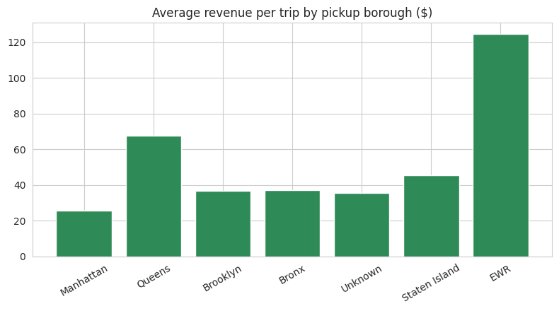
Figure 5: Average revenue per trip by pickup borough
- The top 10 zones out of 258 produce 40.5% of all revenue. The two airports rank first and second even though they are only 2 zones.
- Manhattan has 87.0% of pickups and 74.5% of revenue ($25.73 per trip). Queens has only 9.4% of pickups but 21.1% of revenue, because it holds both airports ($67.45 per trip).
- Brooklyn (3.0% of trips, $36.48 per trip) and the Bronx (0.4%) pay more per trip than Manhattan but have very little volume. The high-value zones outside Queens (for example Park Slope at $39.85) are small, so they do not change the fleet strategy.
- Manhattan zones are busy but low-value per trip (about $22 to $30). The Upper East Side zones have many trips but the lowest value of the top 10 ($21.58 and $22.37).

4.5 Trip length
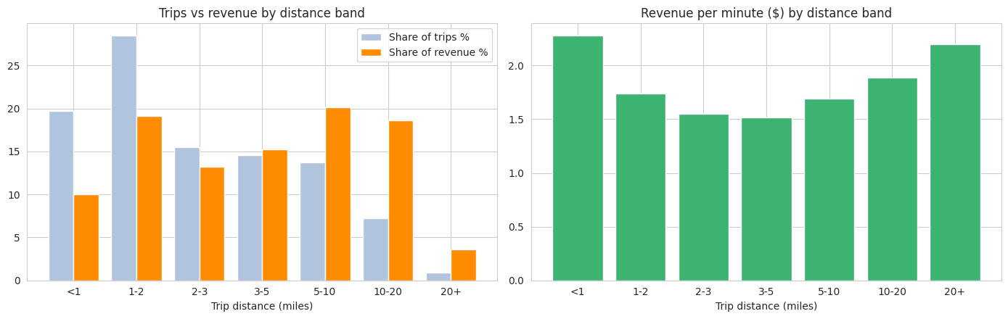
Figure 6: Share of trips and revenue by distance band (left) and revenue per minute (right)
Distance (miles) | Trip share | Revenue share | Per trip ($) | Per mile ($) | Per minute ($)
Under 1 | 19.7% | 10.1% | 15.33 | 21.89 | 2.28
1 to 2 | 28.5% | 19.1% | 20.16 | 13.69 | 1.74
2 to 3 | 15.5% | 13.2% | 25.73 | 10.46 | 1.55
3 to 5 | 14.5% | 15.3% | 31.58 | 8.16 | 1.51
5 to 10 | 13.7% | 20.1% | 44.13 | 6.21 | 1.69
10 to 20 | 7.3% | 18.6% | 77.14 | 5.39 | 1.89
Over 20 | 0.9% | 3.6% | 120.81 | 4.76 | 2.20

- Almost half of all trips (48.2%) are under 2 miles but they bring in only 29.1% of the revenue. Trips of 5 miles or more are 21.9% of the trips and 42.4% of the revenue.
- Revenue per mile falls steadily as trips get longer ($21.89 under 1 mile, $4.76 over 20 miles), because the starting charges are spread over more miles.
- Revenue per minute is U-shaped. Very short trips (under 1 mile, $2.28) and very long trips (over 20 miles, $2.20) are the most efficient, and the middle (2 to 5 miles, $1.51 to $1.55) is the worst. Short trips pay well per minute because of the starting charge. Long trips likely pay well per minute because they are driven at higher speed and often include airport and toll charges.

4.6 Payment method and tips
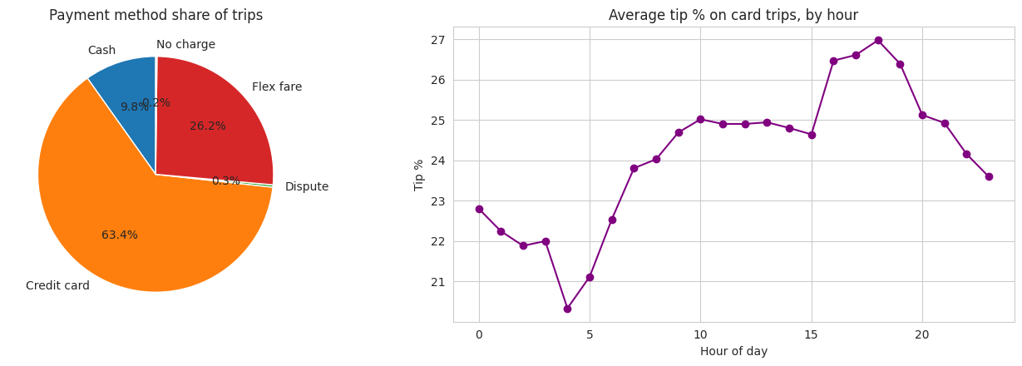
Figure 7: Payment method share (left) and average tip % on card trips by hour (right)
Payment type | Trips | Share | Revenue per trip ($) | Average tip ($)
Credit card | 1,987,971 | 63.4% | 29.89 | 4.28
Flex Fare | 822,664 | 26.2% | 31.64 | 0.31
Cash | 308,215 | 9.8% | 26.95 | 0.00
Dispute | 10,167 | 0.3% | 30.87 | 0.00
No charge | 5,624 | 0.2% | 25.23 | 0.00

- Card is the main payment method (63.4%). Cash is under 10% of trips and has the lowest revenue per trip of the three main payment types ($26.95).
- Flex Fare is a large group (26.2% of trips) and earns slightly more per trip ($31.64), but the data shows almost no tips on it ($0.31 on average). This suggests tips on these app trips are paid outside the meter record, so they cannot be analysed here.
- On card trips the average tip is $4.28, which is 16.7% of the amount before the tip. The 25.0% in the KPI table is the average of the tip percentages of single trips, and it is higher because short, cheap trips often get a large percentage tip (for example $2.30 on a $6.50 fare). The pattern by hour is still useful: tips are highest from 16:00 to 18:00 (about 26.5% to 27%) and lowest at 04:00 (about 20%).

4.7 Airport trips
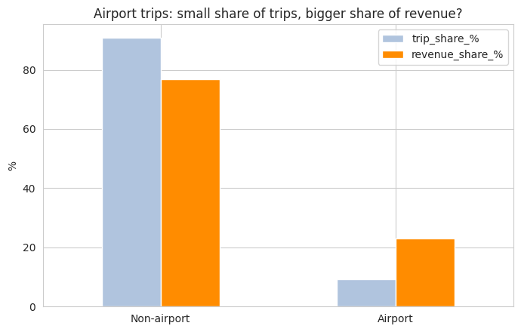
Figure 8: Airport trips are a small share of trips but a large share of revenue
 | Non-airport | Airport
Trips | 2,846,893 (90.8%) | 287,748 (9.2%)
Revenue | $72.5 million (76.9%) | $21.7 million (23.1%)
Revenue per trip | $25.45 | $75.58
Average distance | 2.81 miles | 12.95 miles
Average duration | 15.3 min | 36.5 min
Revenue per trip-minute | $1.66 | $2.07
Average tip % (card trips) | 25.4% | 21.5%

- An airport trip is worth about three times a normal trip ($75.58 against $25.45) and also earns more per minute ($2.07 against $1.66, about 25% more).
- Airport trips earn less per mile ($5.84 against $9.06) but more per minute, so the key advantage is that a car stays busy on a long, high-value trip rather than doing many slow city trips.
- JFK is the single most valuable pickup zone (145,049 pickups, $77.54 per trip), ahead of LaGuardia (84,709 pickups, $68.43).
- The airport flag includes trips that end at an airport. A driver who drops a passenger at an airport has to come back, and only airport pickups can fill that return leg.

5. Business Insights
- Busy is not the same as profitable. The evening peak has the most demand, but the early morning (04:00 to 06:00) has the highest revenue per minute, and midday (11:00 to 15:00) the lowest. The reason is traffic speed (11.6 mph on average), so the fleet should not simply put the most cars on the road at the busiest time.
- The business depends on a few places. Two airport zones and eight Manhattan zones make up 40.5% of revenue. Airports in particular are 9.2% of trips and 23.1% of revenue, so they are a very high-value group.
- Revenue is made by long trips. Trips of 5 miles or more are about 1 in 5 trips (21.9%) but earn 42.4% of the revenue. The short trips are most of the volume but a small part of the money.
- The week has one clear top day and one weak day. Saturday evening is the highest-demand slot in the month, and Monday is the weakest day. Weekdays and weekends pay about the same per trip, so the difference is volume.
- The tip story is incomplete. Flex Fare is more than a quarter of trips (26.2%), and the tip data for these trips is almost empty. Any report on driver earnings based on this data alone will understate them.
- Outer boroughs are not a growth opportunity from this data. Brooklyn and the Bronx pay more per trip but are only 3.4% of the trips, so Manhattan and the airports remain the core of the business.

6. Recommendations
# | Action | Evidence | How to measure
1 | Schedule more cars between 17:00 and 22:59 and on Saturday evening; reduce cars from 11:00 to 15:00 and use that window for maintenance and driver breaks. | 35.7% of trips in 17:00 to 22:59; Saturday 18:00 is the busiest slot; $1.60 to $1.65 per minute at midday. | Revenue per car-hour by shift; idle time in the evening peak.
2 | Create a small early-morning group (04:00 to 06:00) aimed at airport and long trips. | $2.05 per minute at 05:00 and $33.42 per trip, the best of the day, with only 30,967 trips. | Revenue per trip-minute and waiting time at 04:00 to 06:00.
3 | Make airports a daily strategy: drop-offs should be followed by a return pickup at JFK or LaGuardia. | 9.2% of trips but 23.1% of revenue; $2.07 against $1.66 per minute; JFK $77.54 per trip. | Airport share of the fleet's revenue; average wait at the airport queue.
4 | Position cars in Midtown Center, Penn Station and Times Square in the evening. | Top 10 zones produce 40.5% of revenue; these three are the biggest Manhattan zones by revenue. | Time from drop-off to next pickup in these zones.
5 | Use dispatch to mix in 5-mile-plus trips where possible, and avoid long waits for short trips. | Trips of 5+ miles are 21.9% of trips but 42.4% of revenue. | Share of trips over 5 miles per car; revenue per trip.
6 | Push card payment and fix tip capture on Flex Fare trips, then repeat the tip analysis. | 26.2% of trips show $0.31 average tip against $4.28 on card; cash is under 10% of trips. | Share of trips with a recorded payment and tip; tip % after the fix.

Size of the opportunity (simple illustration, not a forecast): if a car replaces a midday minute ($1.60) with an early-morning minute ($2.05) it earns $0.45 more, which is about $27 per paid hour. Replacing a normal-trip minute ($1.66) with an airport minute ($2.07) is worth $0.41 more, or about $25 per paid hour. Real results depend on waiting time, which this data does not show.

7. Limitations
- One month only (August 2026, a summer month). Seasons, school terms, holidays and weather are not covered, so the hourly and weekly patterns should be checked against other months before big decisions.
- Revenue is passenger spend and includes taxes, surcharges and tolls. It does not include costs such as fuel, leasing, insurance or driver pay.
- Revenue per minute counts only the time with a passenger. Waiting and searching time is not in the data, so earnings per working hour will be lower than the numbers shown.
- Tips are recorded for card trips only. Flex Fare tips are almost missing, so tip results cover 63.4% of trips.
- The data is for the whole yellow taxi industry, not for one fleet, so the recommendations are directions to test with the fleet's own data.
- Averages hide differences between trips. The median fare ($15.60) is half of the average trip revenue ($30.05).

8. Conclusion
The best way to increase earnings is to concentrate cars where each paid minute is worth the most: airports, long trips, evening peaks in Midtown, and the quiet early-morning hours, while using the slow midday period to rest cars and drivers. These findings come from 3.1 million real trips, and the next step is to repeat the same notebook for other months and for the fleet's own trip data.

Project files
- Notebook: Task5_Analytics_Report.ipynb (Google Colab, Python)
- GitHub folder: https://github.com/Santoshgutte1522/data-engineer-internship/tree/main/Task5_Analytics_Report
- Data: NYC TLC Trip Record Data (yellow taxi, August 2026) and Taxi Zone Lookup, downloaded directly by the notebook.

